NAAN MUDHALVAN

TITLE : LOGO CREATION

USER NAME : 67F6CF7AEAE3B5CBCBC43CBB46746FBB

1.Open canva 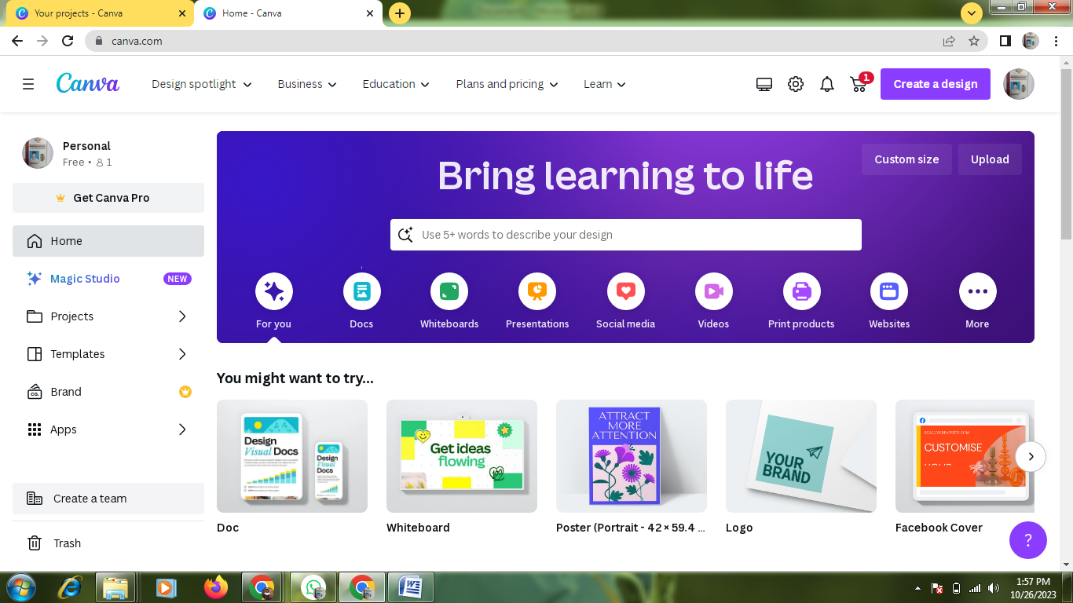

2.select a template 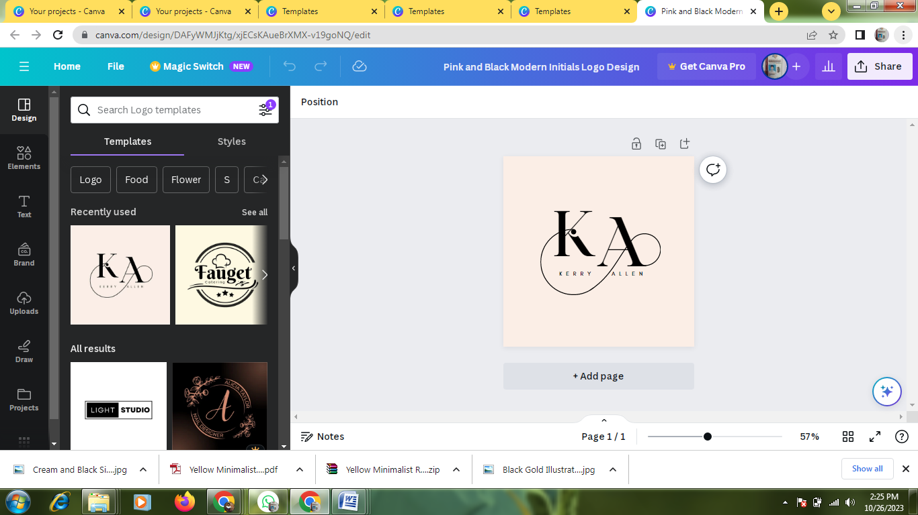

3.Edit a details 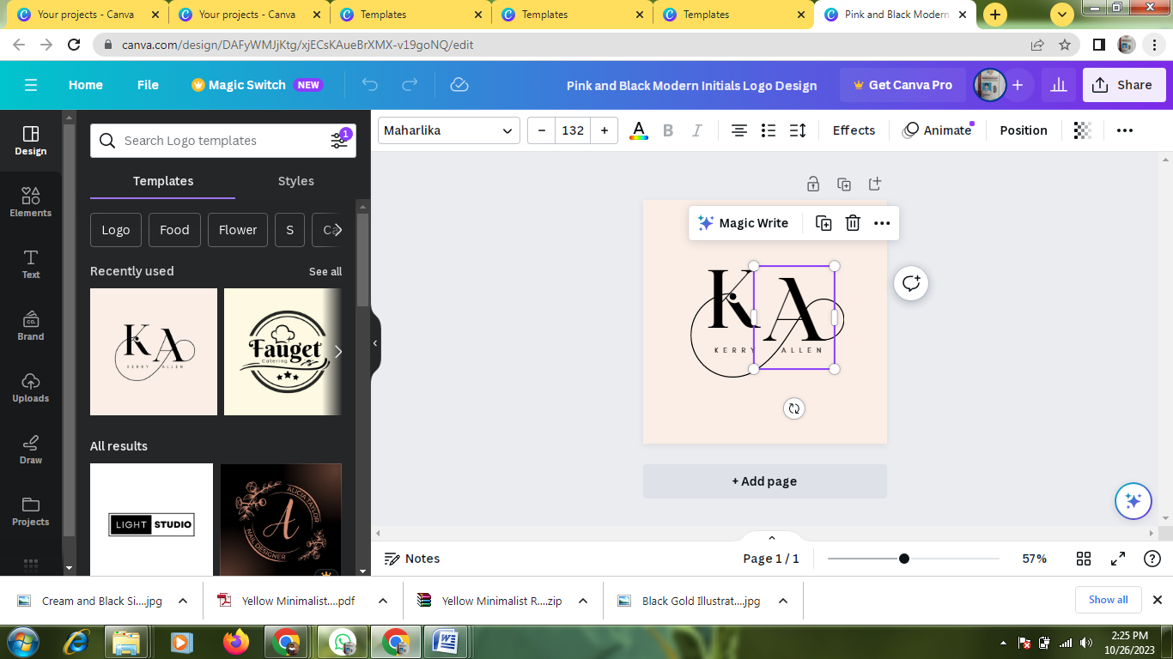

4.Pdf covert 